**BD 110 SOL 1:**

Sending in gonio = -4.355 to -7.743

= delete 1:28 and 60:end

= keep 29:59

Ankle rotation SOL1: **-0.25974** mm/deg (start gonio angle 4.4524, norm angle 4.4524).

Original SOL data:

Ankle rotation SOL1: -0.13157 mm/deg (start gonio angle 1.3053, norm angle -1.0917).

Ankle rotation SOL2: -0.039252 mm/deg (start gonio angle 0.1896, norm angle -0.12488).

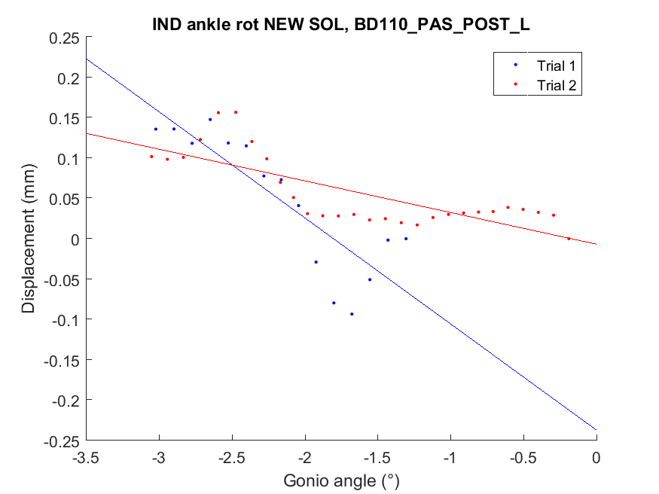

**BD 110 GMMTJ 2:**

Relationship is very linear (x = angle, y = displ)



Automatic data accepted:

Ankle rotation GMMTJ2: -0.92678 mm/deg (start gonio angle 0.06917, norm angle -0.26863).

Original GMMTJ data:

WARNING: GMMTJ1 Recording starts after 3!!!! degrees dorsiflexion. DISCARD? Norm starting angle = -3.0351.

Ankle rotation GMMTJ2: -0.92678 mm/deg (start gonio angle 0.06917, norm angle -0.26863).

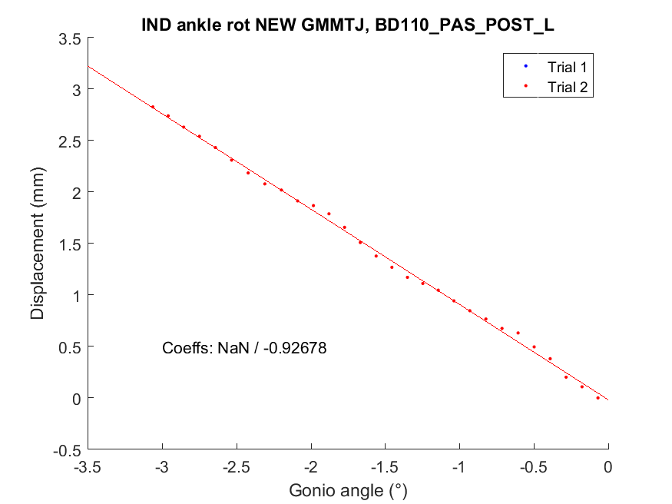

**Checking GMMTJ 2:**

Keep data from beginning (ca -3 deg) to -6.083 deg

**Ankle rotation GMMTJ1: -0.62441 mm/deg (start gonio angle 3.0351, norm angle NaN).**

**BD102_PAS_POST_L**

SOL:

Keeping data for angles: -0.5995 to -5.186

= keep datapoints 24:67

Ankle rotation SOL2: **-0.17347** mm/deg (start gonio angle 0.59946, norm angle 2.0276).

Original SOL data:

Ankle rotation SOL1: -0.13101 mm/deg (start gonio angle -1.8545, norm angle 1.8883).

Ankle rotation SOL2: -0.12047 mm/deg (start gonio angle -2.0297, norm angle 2.0276).

